**B.M.S College of Engineering**

**P.O. Box No.: 1908 Bull Temple Road,**

**Bangalore-560 019**

**DEPARTMENT OF INFORMATION SCIENCE & ENGINEERING**



**Course – Java Programming**

**Course Code – 19IS4PCJAV**

**Final report on Project work**

**VEHICLE TOLL GENERATOR**

Submitted to – [Shubha Rao V](mailto:shubha.ise@bmsce.ac.in)

Submitted by -

Darshan Hirani 1BM19IS046

Pranav Kulkarni 1BM19IS217

**B.M.S College of Engineering**

**P.O. Box No.: 1908 Bull Temple Road,**

**Bangalore-560 019**

**DEPARTMENT OF INFORMATION SCIENCE & ENGINEERING**



**CERTIFICATE**

Certified that the Project has been successfully presented at **B.M.S College Of Engineering** by **Darshan Hirani and Pranav Kulkarni**, bearing USN: **1BM19IS064 and 1BM19IS217**, in partial fulfillment of the requirements for the IV Semester degree in **Bachelor of Engineering in Information Science & Engineering**of **Visvesvaraya Technological University, Belgaum** as a part of the course **JAVA programming  *(*19IS4PCJAV)** during academic year 2020-2021.

**Faculty Name –** [Shubha Rao V](mailto:shubha.ise@bmsce.ac.in)

**Designation –**

**Department of ISE, BMSCE**

**TABLE OF CONTENTS**

|  |  |
| --- | --- |
| Abstract | 4 |
| Problem statement | 5 |
| Introduction | 6 |
| Overview of the project |  |
| High level design |  |
| Tools used |  |
| Implementation/ Code |  |
| Results/ Snapshot |  |
| References |  |

**ABSTRACT**

In some situations, the process of toll collection is a manual one. This is often the case with toll roads and bridges. An individual designated as a toll collector, is positioned at a strategic point where it is possible to collect the fee or charge from anyone who wishes to cross the bridge or continue along the road. The aim of this project is to make this system electronic and online based to overcome these drawbacks. Java based model has been create to let the user make a trip and route chosen using the Dijkstra's algorithm and the toll is calcuted accordingly.

**PROBLEM STATEMENT**

To build a tool with a graphical user interface which depicts the working model of a Electronic toll collector (ETC), calculate the toll to be paid and display the final receipt on the swing window along with the Personal and Vehichle details.

**INTRODUCTION**

Manual toll collection is most widely used collection method in India. It requires a toll collector or attendant. Based on the vehicle classification, cash toll is received by the collector. Due to manual intervention, the processing time is highest. Electronic Toll Collection (ETC) is a system that automatically identifies a vehicle equipped with a valid encoded data tag or transponder as it moves through a toll lane or checkpoint. ETC increases the lane throughput because vehicles need not stop to pay the toll. Hence, wastage of man power, fuel and time can be avoided.

**OVERVIEW OF THE PROJECT**

**Inputs:**

1. **Personal Details**
2. **Vehicle Details**
3. **Trip Details**

**Data Stored in Files:**

**Output:**

**Key Java concepts used:**

1. Packages - a grouping of related types providing access protection and name space management
2. Inheritance - capability of a class to derive properties and characteristics from another class
3. Objects and Classes
4. Abstract classes
5. Constructors (Default and Parameterized)
6. Interfaces
7. Graphs (Dijkstra's algorithm)
8. Exception Handling
9. File Handling
10. Collections Framework (ArrayList)
11. Hash Sets
12. Serialization and Deserialization

**HIGH LEVEL DESIGN**

**TOOLS USED**

1. An Integrated Development Environment
2. Java Swing - a lightweight and platform independent GUI widget toolkit. It is used for creating window based applications. It includes components like buttons, scroll bars, text fields etc.
3. Git for version control for team collaboration
4. Java Abstract Windowing Toolkit

**IMPLEMENTATION**

Enter the code here:

----

Link to GitHub repository:

**RESULTS / SNAPSHOTS**

The final receipt including the Details of the driver, vehicle detail and the Total amount of Toll to be paid

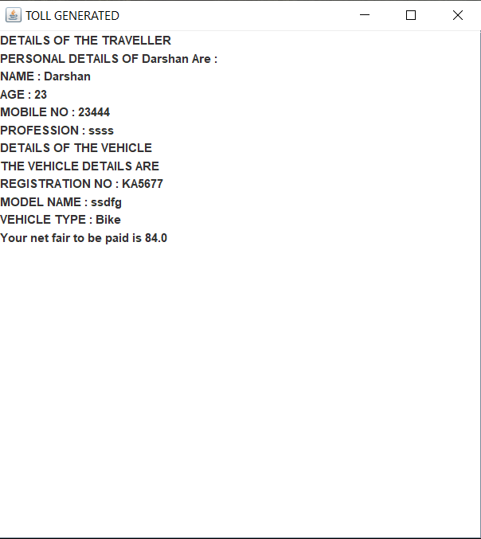

**REFERENCES**

1. [java the complete reference, 7th edition -herbert schildt.pdf - Google Drive](https://docs.google.com/file/d/0BxbayAAcS8Iid1RfMFRGYklBRlE/edit?resourcekey=0-hCGaBa_dX871VQLF5eiUUg)
2. [HashMap in Java with Examples – GeeksforGeeks](https://www.geeksforgeeks.org/java-util-hashmap-in-java-with-examples/)
3. [ArrayList in Java – GeeksforGeeks](https://www.geeksforgeeks.org/arraylist-in-java/)
4. [Java Swing How to - Implement jTable from Arraylist (java2s.com)](http://www.java2s.com/Tutorials/Java/Swing_How_to/JTable/Implement_jTable_from_Arraylist.htm)
5. [Java Swing Tutorial - javatpoint](https://www.javatpoint.com/java-swing)